

***STUDY OF VEDIO GAMES USING***

***GRAPH ANALYSIS***

*Course #: ALY6110*

*Course Name: Data Management & Big Data*

*Professor: Richardo Checchi*

*Submitted By:*

***Group 1:***

*1. SHIKSHA ARORA*

*2. AMAN WANGDE*

*3. MENGI LU*

*4. XINKANG WANG*

*5. HARIPRASATH PERIYASAMY*

*Academic Term: Fall 2017- Session A*

*Date of Submission: 10/28/2017*

**TABLE OF CONTENTS**

1. VIDEO GAMES…………………………………………………………………...3

2. BIG DATA ON VEDIO GAMES………………………………………………....3

3. NEO4J SOFTWARE……………………………………………………………....4

3.1 GRAPHICAL ANALYSIS OF VEDIO GAME……………………………..4

3.2 ANALYSIS BASED ON USER SCORE & CRITIC SCORE……………....8

3.3 ANALYSIS BASED ON SALES OF GAMES …………………………….10

3.4 ANALYSIS BASED ON GAME TO PLATFORM………………………….12

3.5 ANALYSIS BASED ON GAME TO YEAR…………………………………12

3.6 ANALYSIS BASED ON PUBLISHER TO PLATFORM……………………13

3.7 ANALYSIS BASED ON PUBLISHER TO YEAR…………………………..13

4. VERIFYING GRAPH ANALYSIS WITH TABLEAU…………………………..14

5. CONCLUSION…………………………………………………………………….17

6. REFERENCES…………………………………………………………………….18

# VIDEO GAMES:

Video games are electronic diversions which can be played through TV, a handheld machine or a PC. In the cutting-edge days, computer game has a noteworthy impact in an individual's life contrasted with some other stimulation. Toward the starting, gaming was accessible in CDs, DVDs or any computerized downloads. These days it’s been worked in with the handheld gadgets and can be downloaded as application in any shape. The absolute most well-known video games in present day times are Xbox, Play stations and Wii U. As the market for gaming industry is developing with times which are greater than music and motion picture industry joined, it is on the ascendance. A portion of the figures are given beneath:

As the market for gaming industry is growing with times which are bigger than music and movie industry combined, it is on the ascendance. Some of the figures are given below:

* More than 2 billion gamers = 50 Tb of data / day.
* AAA multiplayer titles = about 1Tb of data / day from in-game telemetry.
* Social games = 150 GB of data / day.
* In a typical month, EA hosts about 2.5 billion game sessions, representing about 50 billion minutes of game play.

Each Video Game that is being released in market is given a ESRB rating depending upon the content in the game.

Below is the list of rating along with its meaning:

**ESRB RATING:**

|  |  |
| --- | --- |
| AO | Adult Only (18+) |
| E | Everyone |
| E10+  Same | Everyone 10+ |
| EC | Early childhood |
| K-A | Kids to Adults |
| M | Mature (17+) |
| RP | Rate Pending |
| T | Teen (13+) |

# BIG DATA ON VIDEO GAMES:

Gaming has turned out to be significant supporter of enormous information. Since the recreations occur in virtual world each part of diversion must be measured. For measuring this sort of data and recording it in a storehouse, enormous information assumes a huge part. The contact with the game doesn't end when play stops. The player will post their diversion details via web-based networking media and contrast game notes and others in Reddit discussions. The measure of engagement and dedication is widely inclusive in their lives. Contrast that with the level of engagement on a managing an account application.

Because this level of inclusion and the measure of individual information created, game makers can make a situation suited to the gamers' inclinations. By utilizing different business knowledge devices, for example, Hadoop and promoting computerization. we can likewise utilize these informational collections to ascertain rewards that the player is for the most part liable to acknowledge, creating pioneer sheets that will incite more diversion play, and give the player virtual prizes to give him/her a feeling of accomplishment. Along these lines, the game maker upgrades diversion engagement and maintenance. To store all the data given above, there is a requirement for a colossal database administration framework and all these data not just include content information, it additionally incorporates video, sound and prescient investigation which are a portion of the examination procedure in enormous information.

Enormous information causes game creating time to chop down and gives a virtual space to test, watch diverse arrangements of conditions. It additionally gives more gaming alternative to players and for industry to dissect. The human communications and every other datum which are recorded help the business to take the gaming stage a level up among every single other stage or diversion.

# NEO4J SOFTWARE:

Neo4j is a graph database management system created by Neo4j, Inc. Depicted by its designers as an ACID-consistent value-based database with local diagram stockpiling and handling, Neo4j is the most mainstream chart database as per DB-Engines positioning. Neo4j is accessible in a GPL3-open-source "group release", with online reinforcement and high accessibility expansions authorized under the terms of the Affero General Public License. Neo additionally licenses Neo4j with these expansions under shut source business terms. Neo4j is executed in Java and available from programming written in different dialects utilizing the Cypher Query Language through a value-based HTTP endpoint, or through the double 'jolt' convention.

Yesterday's leap forward applications were driven by enormous information – tomorrow's achievement applications will be driven by associated information. Never again fuelled just by information exchanges, these applications draw together every framework over the whole undertaking.

## 3.1 GRAPHICAL ANALYSIS OF VIDEO GAMES

For the analysis, we have considered two data sets:

1. Video Game ranked as per user and critic score

2. Video Game ranked as per sales in 3 countries North America, Europe and Japan.

**VIDEO GAME DATASET 1 (USER SCORE AND CRITICS SCORE)**

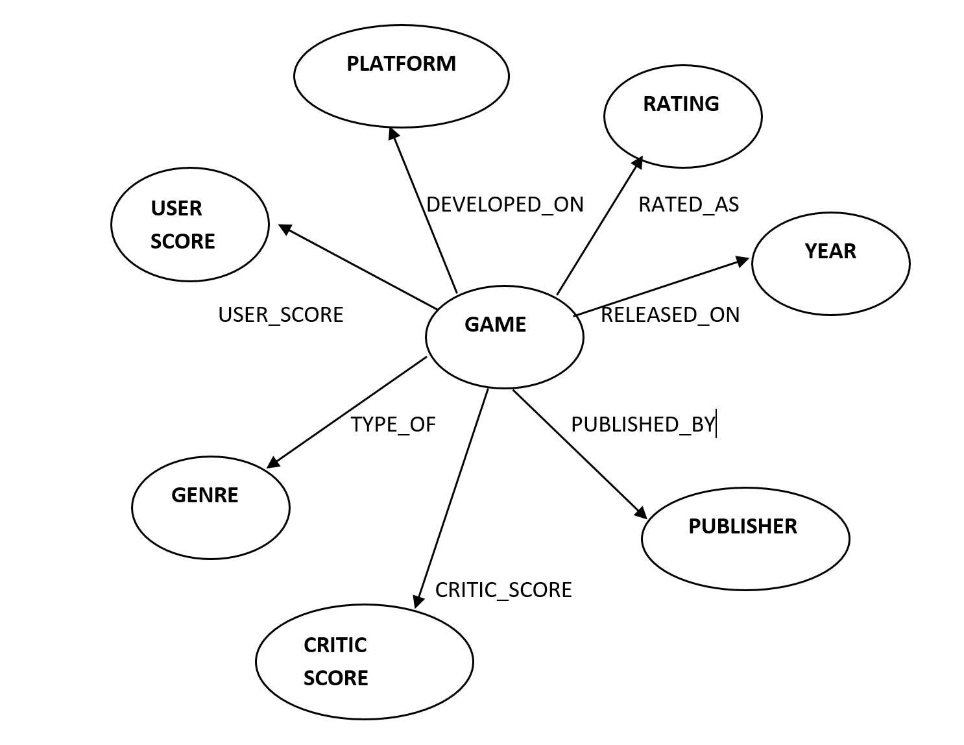

From the above diagram, each “Game” Node has attributes which are also considered as Nodes

Attributes are:

1. Platform
2. Publisher
3. Genre
4. Rating
5. Year
6. User Score
7. Critic Score

Each attribute is connected to Game via a **“relationship”**

For example:

Game: RELEASED_ON: YEAR

Here, RELEASED_ON is a relationship to Nodes Game & Year

**VIDEO GAME DATASET 2 (SALES)**

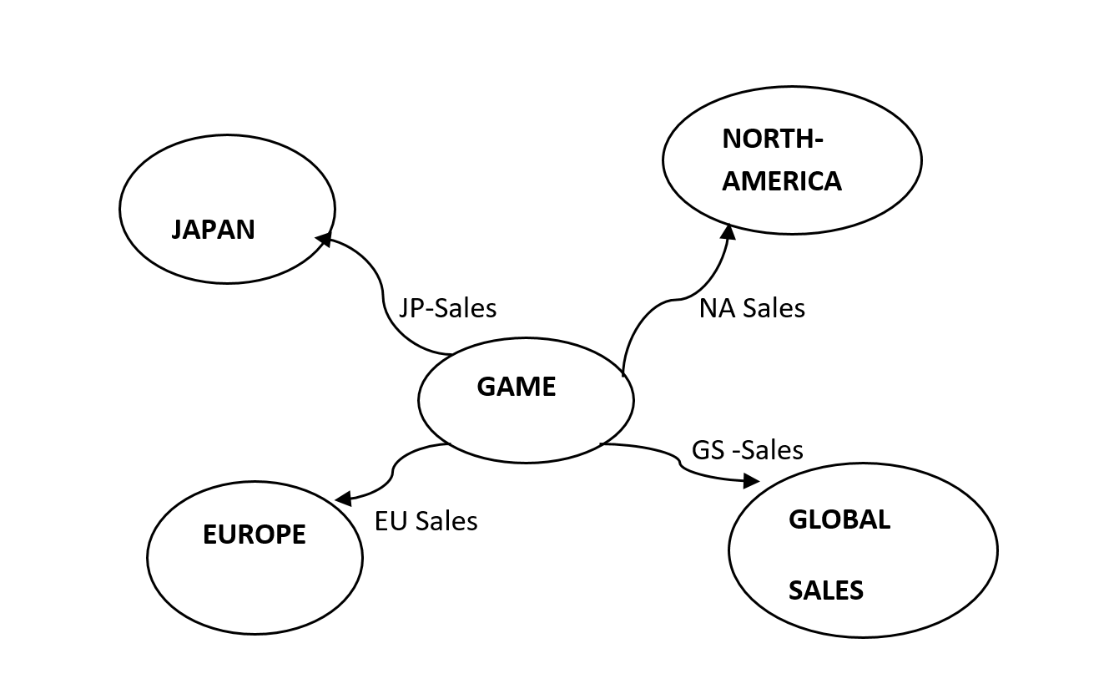

From the diagram above, each Game Node is connected to a Node of Country via a relationship based on the sales in that country.

**GRAPHICAL REPRESENTATION OF DATA IN NEO4J**

For a clear image, the below graphs only show few game nodes and their relationships

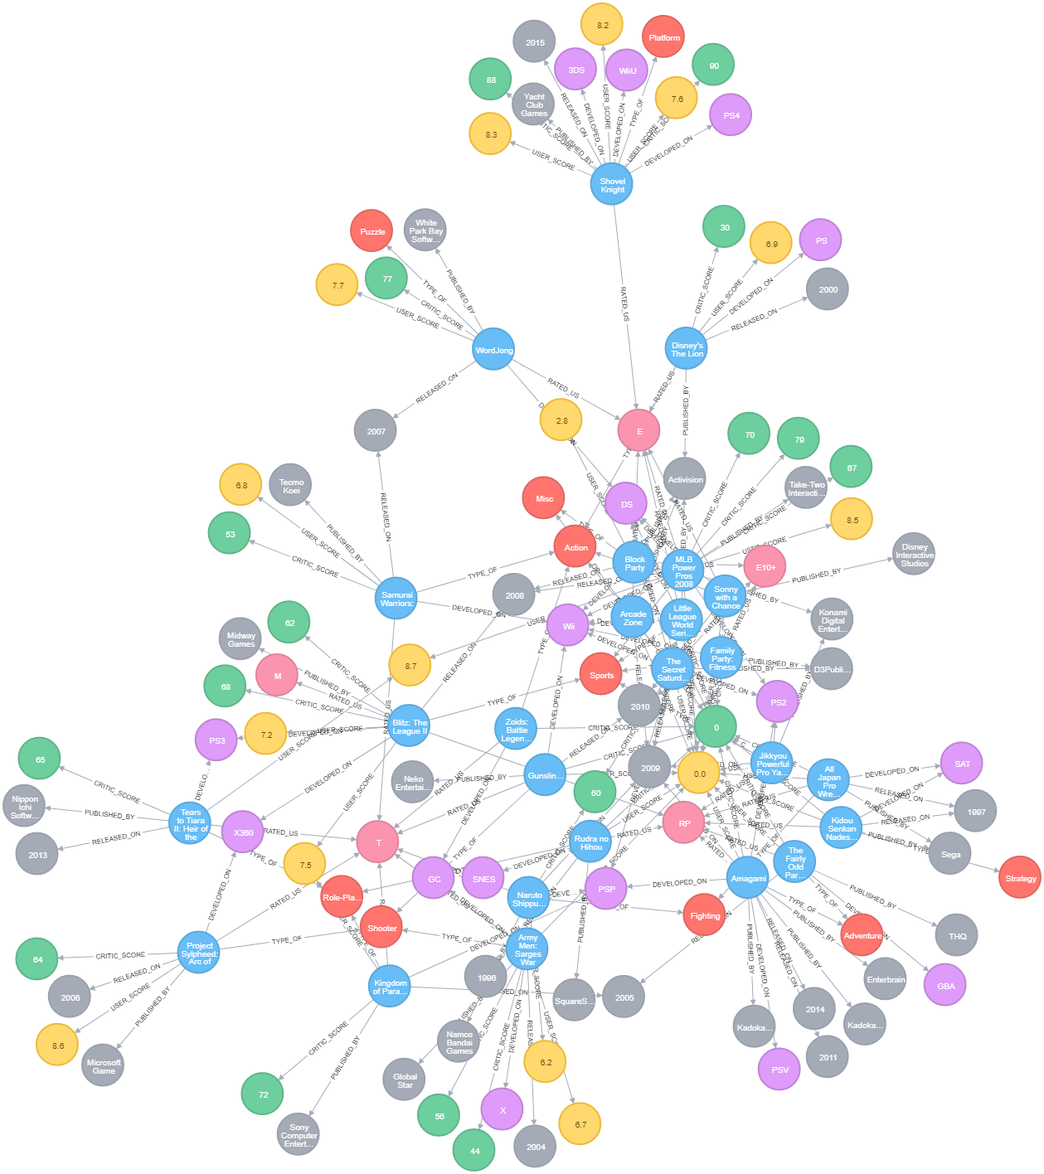

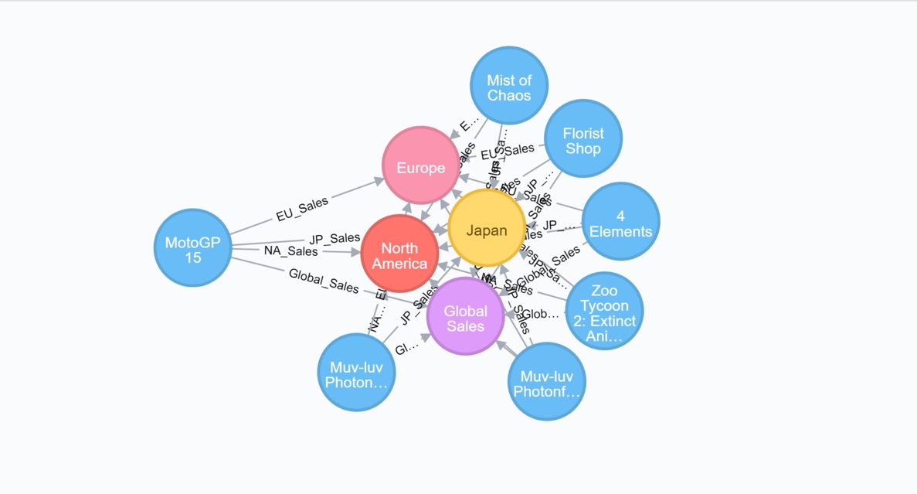

**3.2 ANALYSIS BASED ON THE USER SCORE & CRITIC SCORE:**

1. Top 10 Games which is having high USER SCORE and CRITIC SCORE

Below query results gives the game with maximum user score and critic score which gives a feedback on games popular among users and critics.

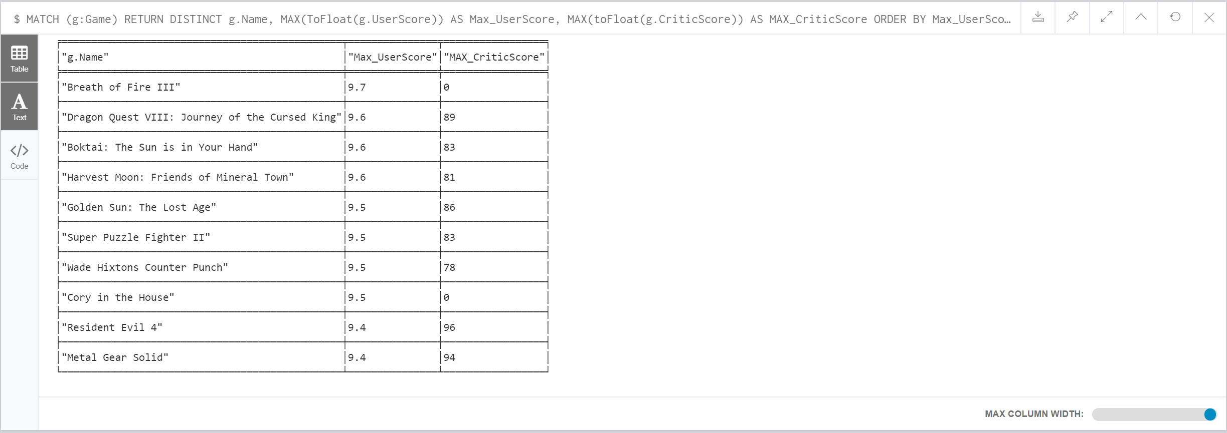

2. Top 10 games with MAX USER_SCORE and Rank

The output below lists the top 10 games with maximum USER_SCORE and Rank.

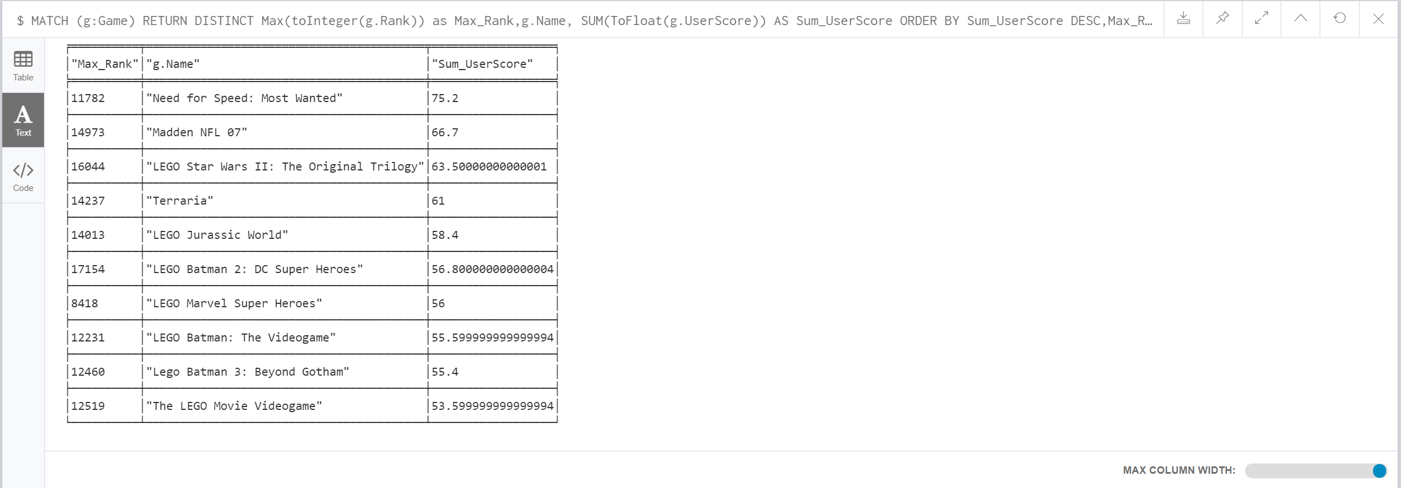

3. Top 10 games with MAX CRITIC_SCORE and Rank

The output below lists the top 10 games with maximum CRITIC_SCORE and Rank.

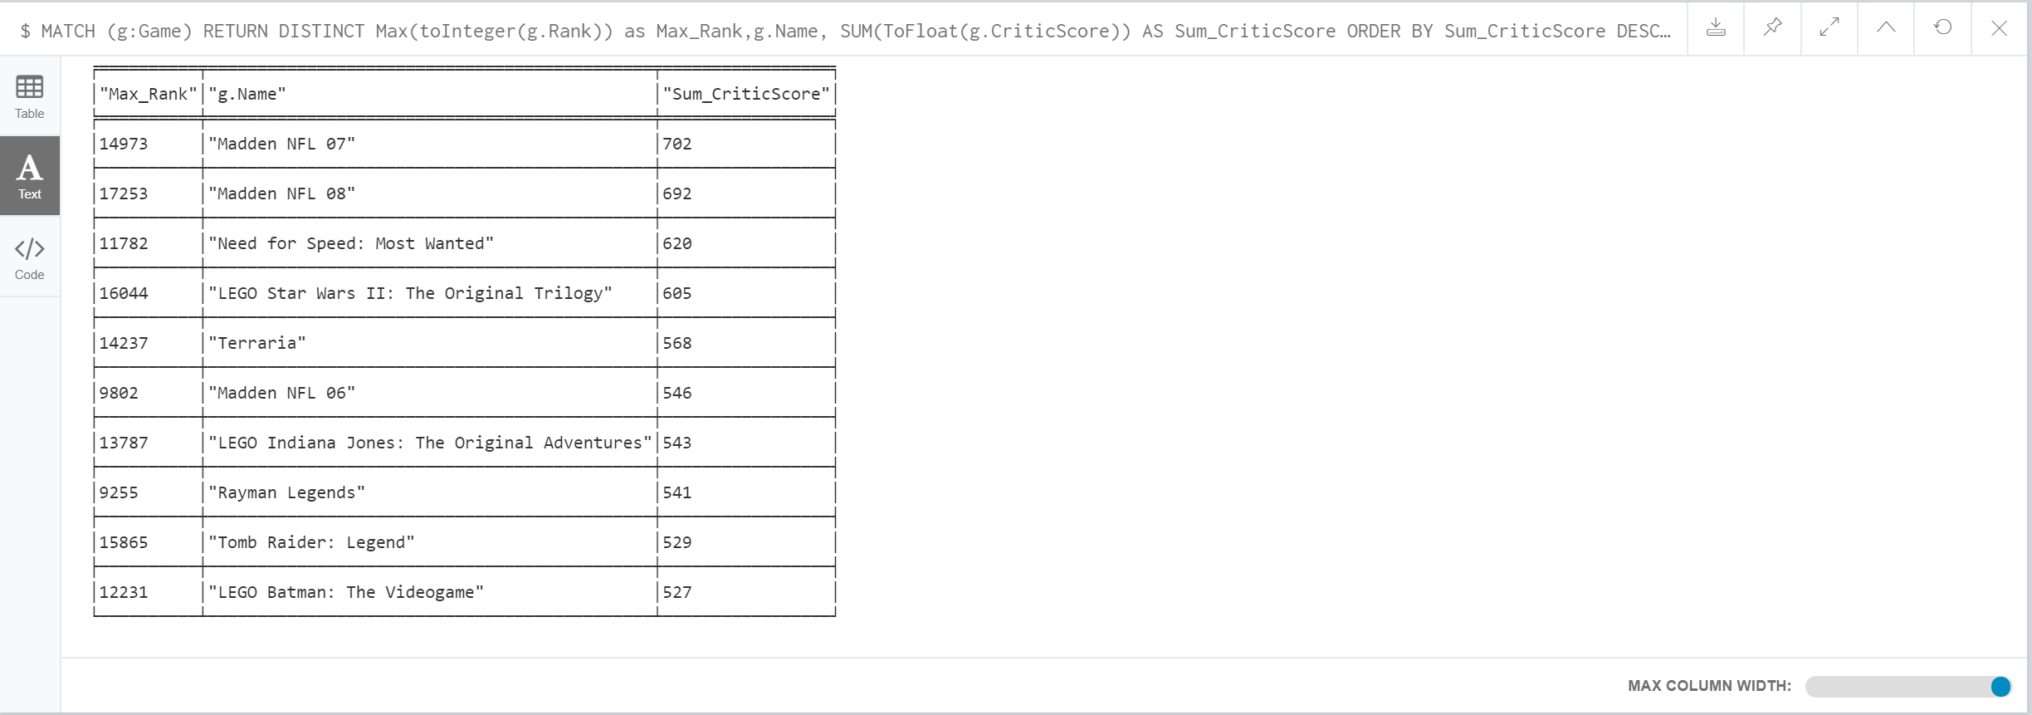

Final Inference:

Below chart lists the top 10 games with maximum USER_SCORE and the CRITIC_SCORE

“Need for Speed: Most Wanted” is very popular amongst the Users, even though it has low CRITIC_SCORE than “Madden NFL 07”

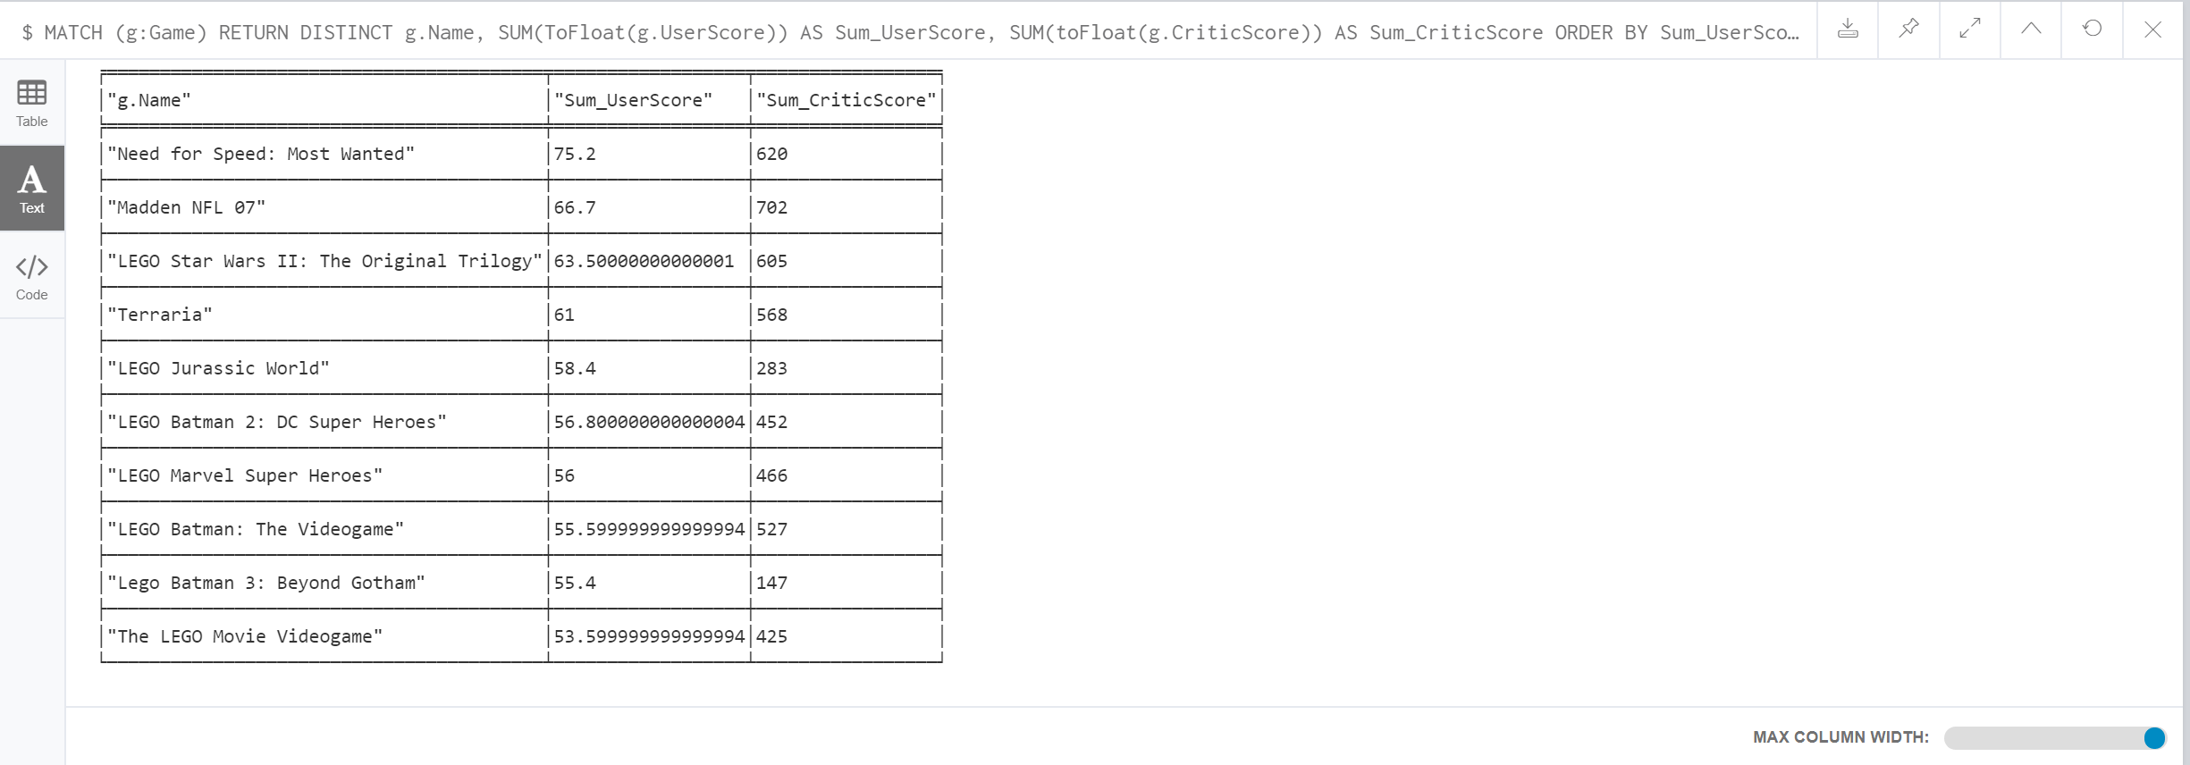

**3.3 ANALYSIS BASED ON GAME SALES**

1. Top 10 Games with Highest No. of Sales in North America

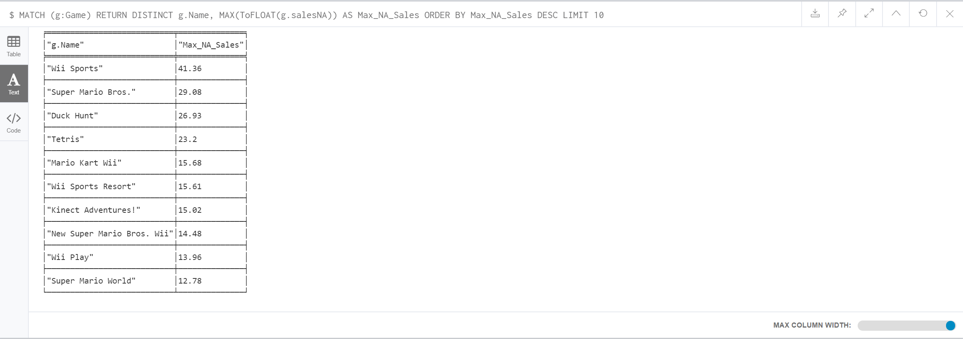

2. Top 10 Games with Highest No. of Sales in Europe

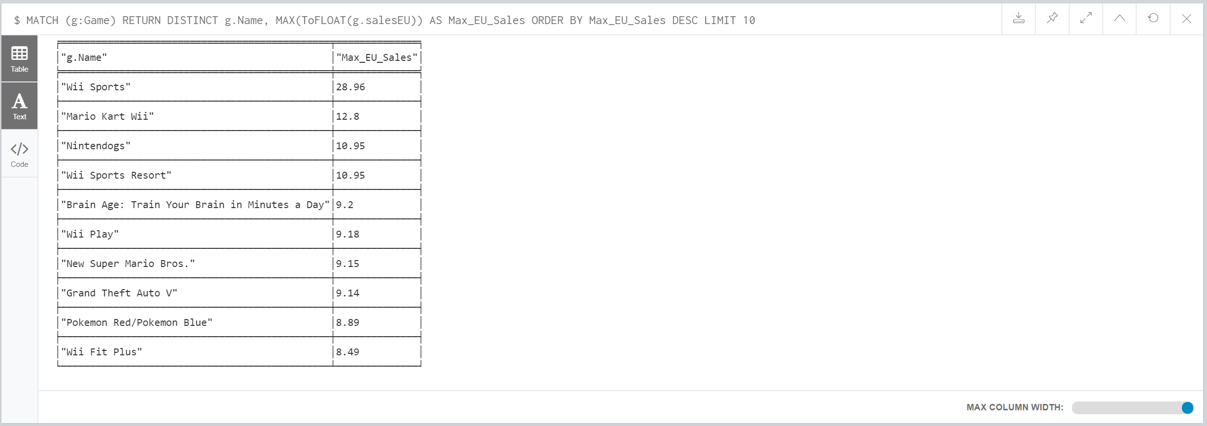

3. Top 10 Games with Highest No. of Sales in Japan

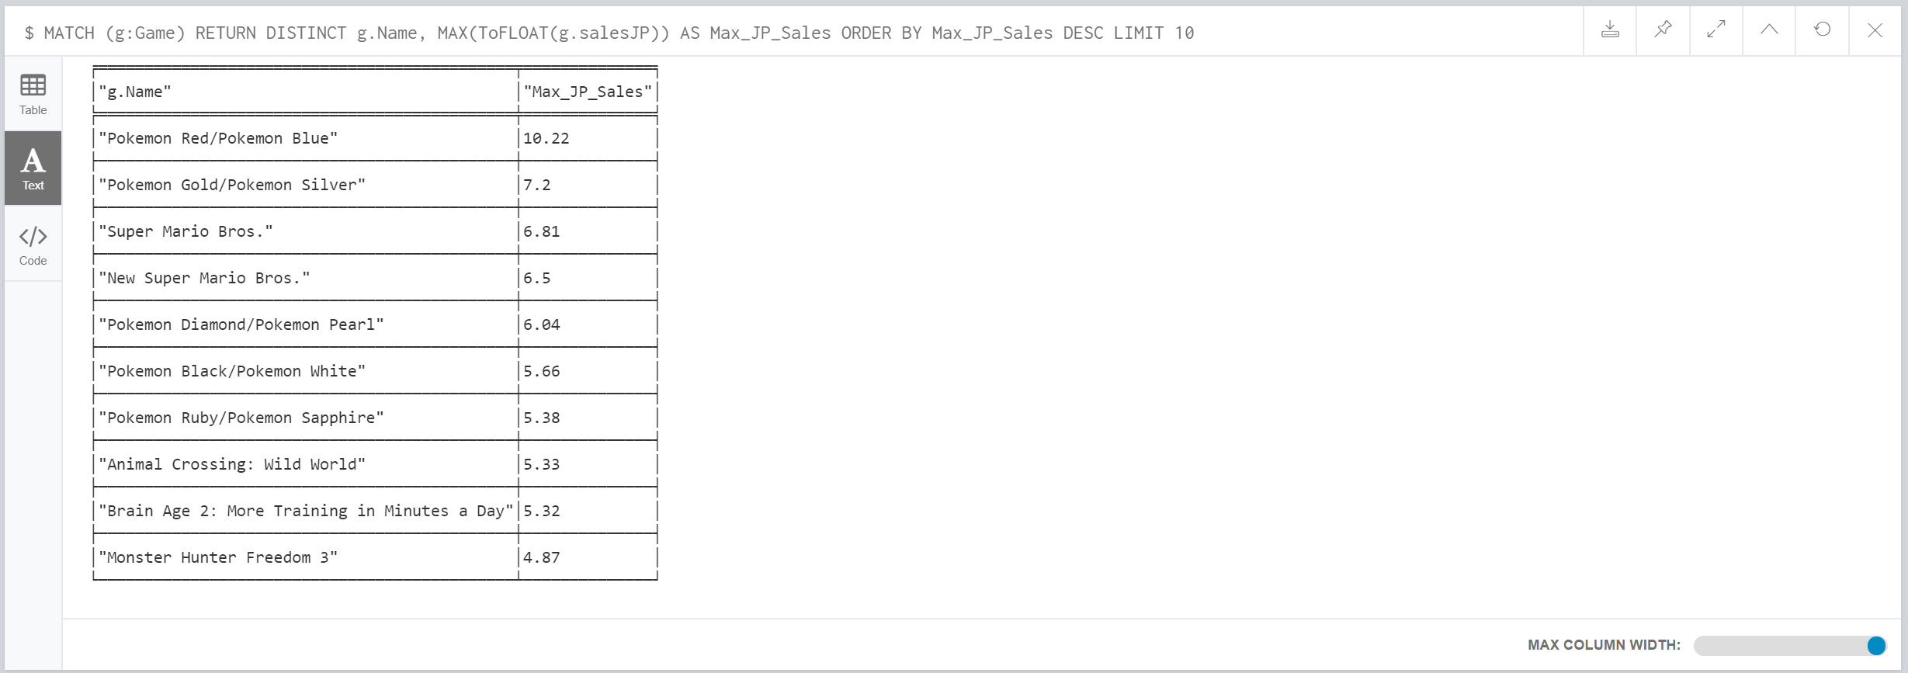

*🡪****Wii Sports has max sales in North America & Europe, but no in Japan***

4. Top 10 Games with Highest No. of Global Sales

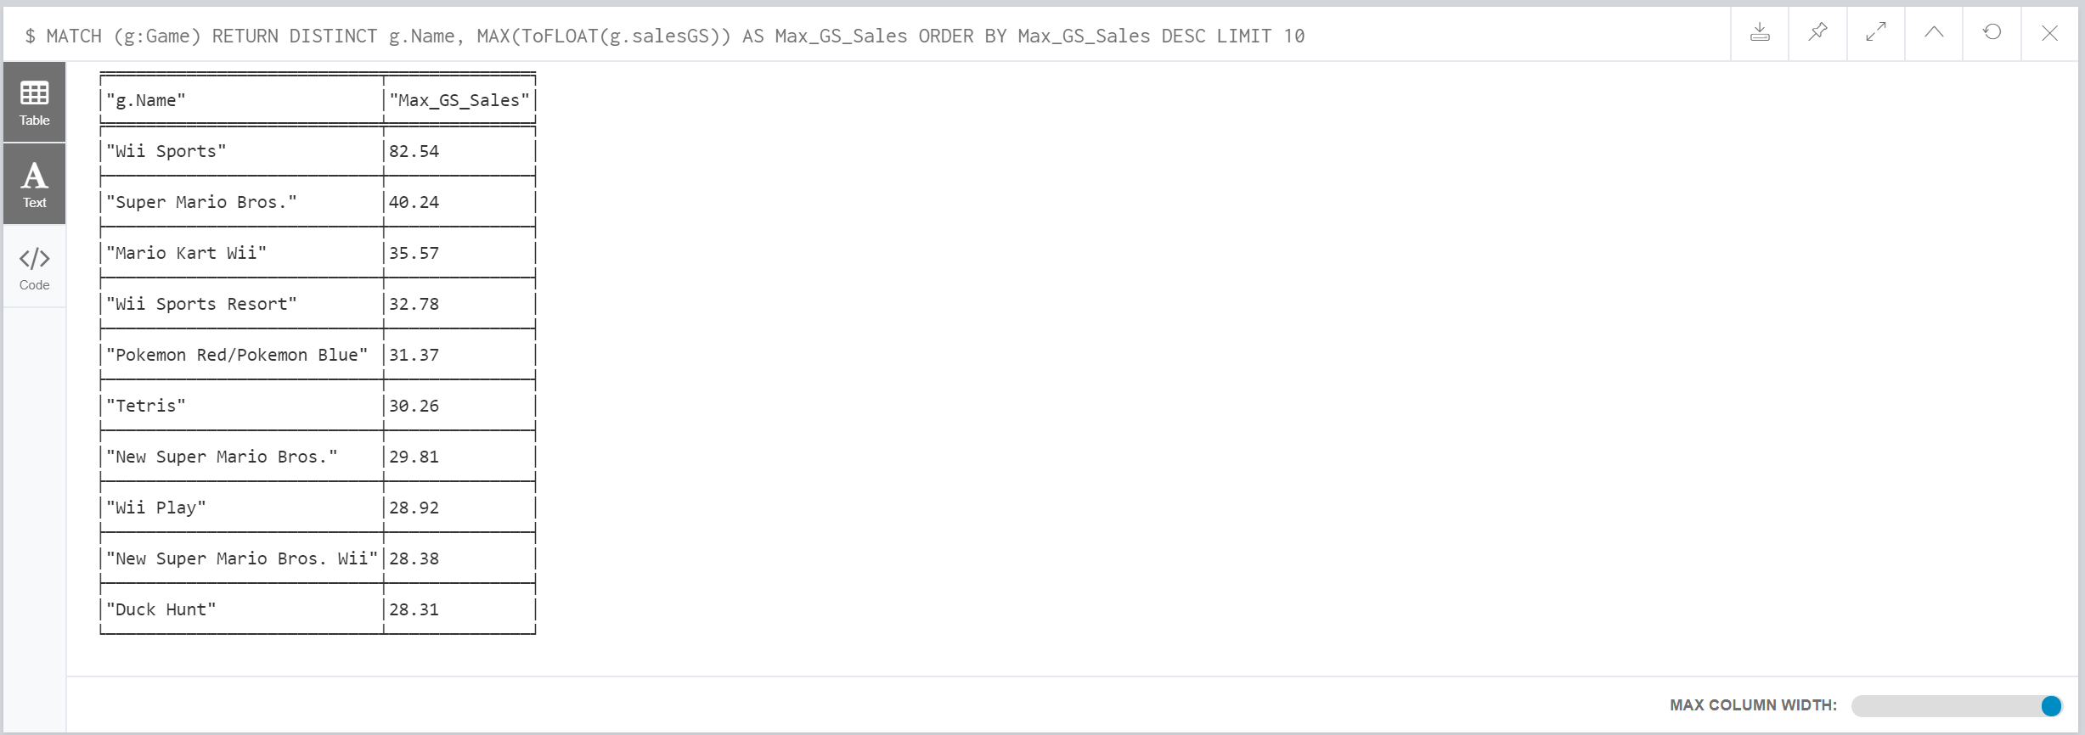

***🡪Wii Sports has max sales in North America & Europe 🡪 Maximum overall Global Sales***

5. Publisher with highest number of sales in North America, Europe, Japan 🡪 *“Nintendo”*

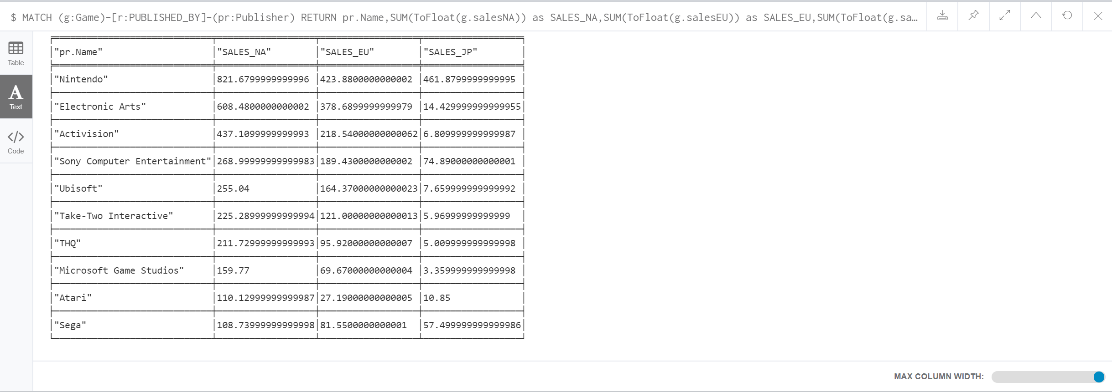

6. Number of Games published by each Publisher. (Top 10 Publishers)

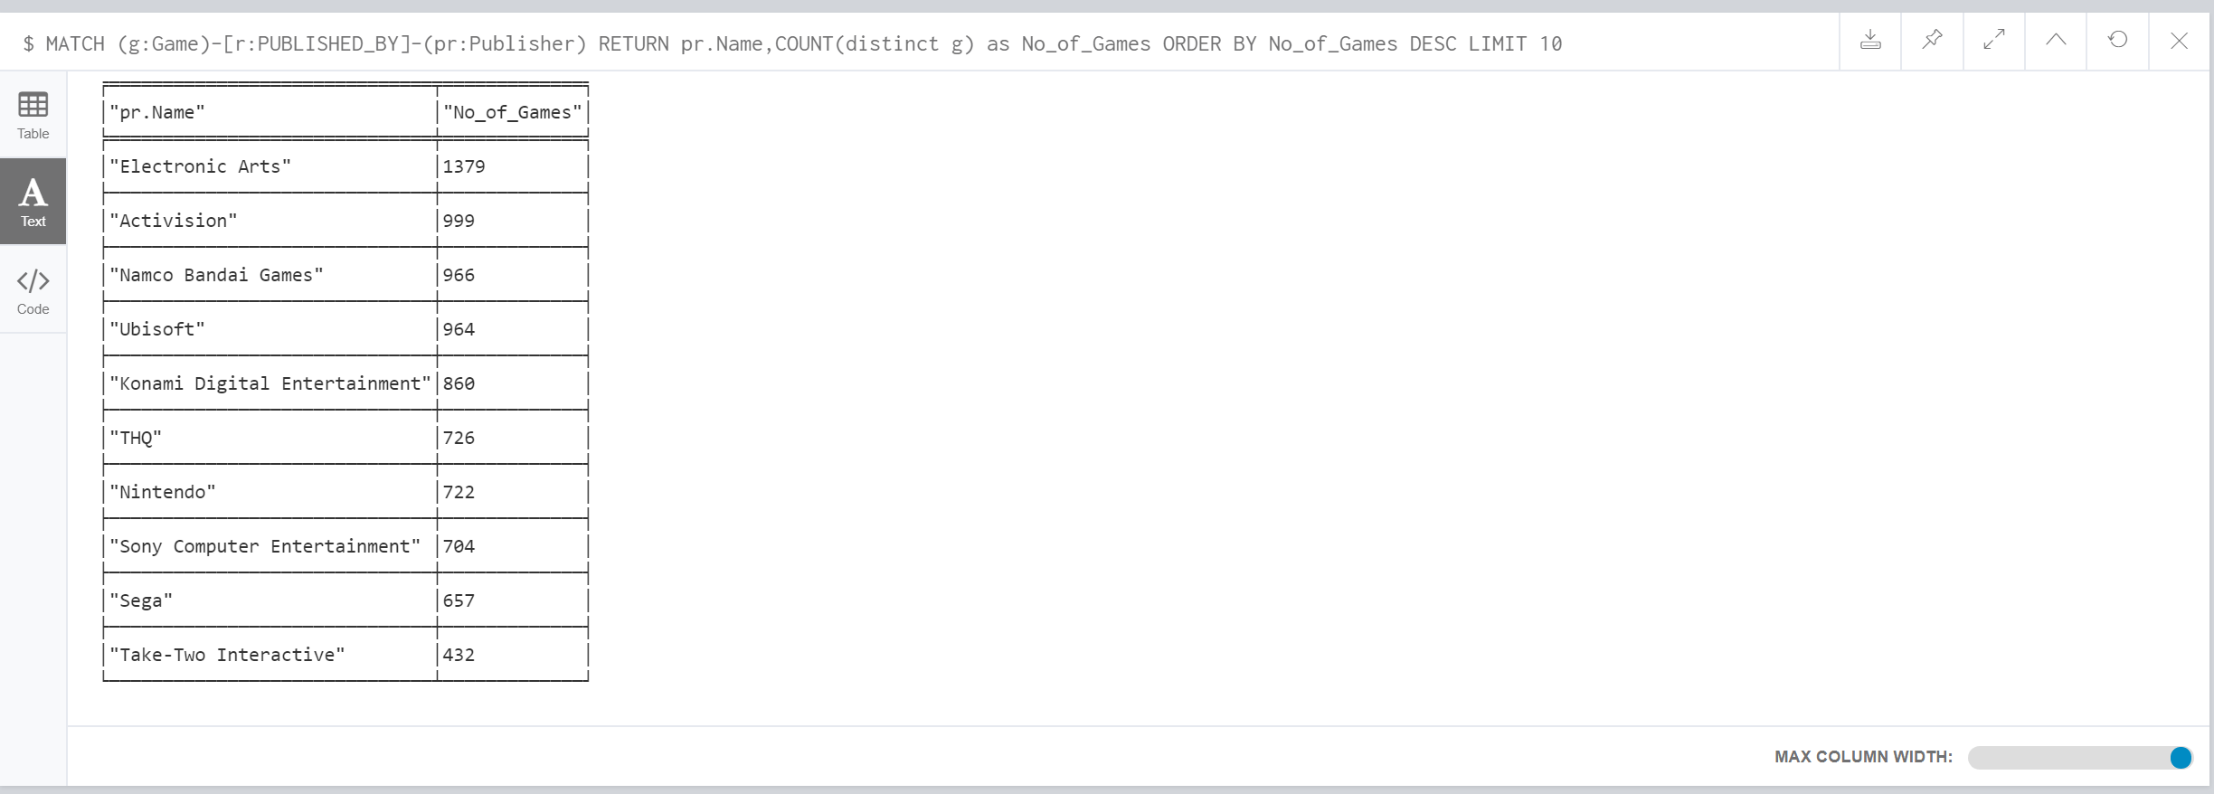

🡪*Even though Nintendo had only published 722 Games 🡪 Yet it had the Highest Number of Sales whereas even though Electronic Arts had published maximum number of games it still was ranked second in terms of sales. This could be possible that Games published by Nintendo are very popular.*

**3.4 ANALYSIS BASED ON GAME TO PLATFORM.**

*🡪From the below chart below we can infer that most of the games are developed on “DS” platforms*

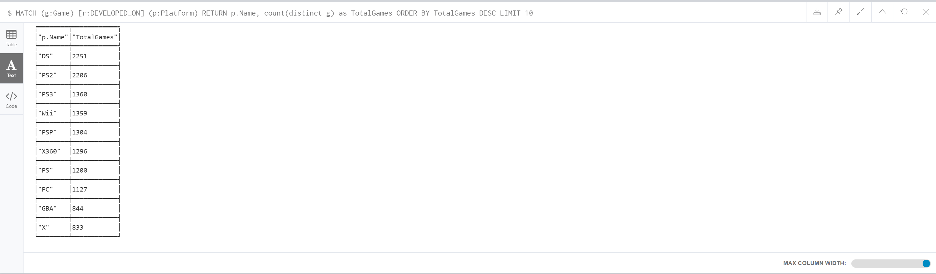

**3.5 ANALYSIS BASED ON GAME TO YEAR**

*🡪From the below chart, we can infer that Maximum Games have been released in the year “2008”*

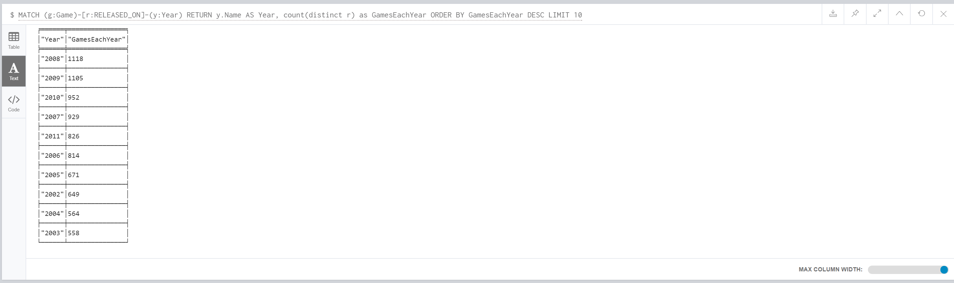

**3.6 ANALYSIS BASED ON PUBLISHER TO PLATFORM**

**🡪** *From the chart below, we can infer that even though games developed on “DS” platform are maximum, yet Games published by “Sony Computer Entertainment” on “PS2” platform are high in number*.

*🡪Also, as “Electronic Arts” has published maximum number of games, we can also get an idea from the below chart, the “Electronic Arts” appears multiple times in result with maximum games developed on PS2,X360,PC, & PC3 platforms*

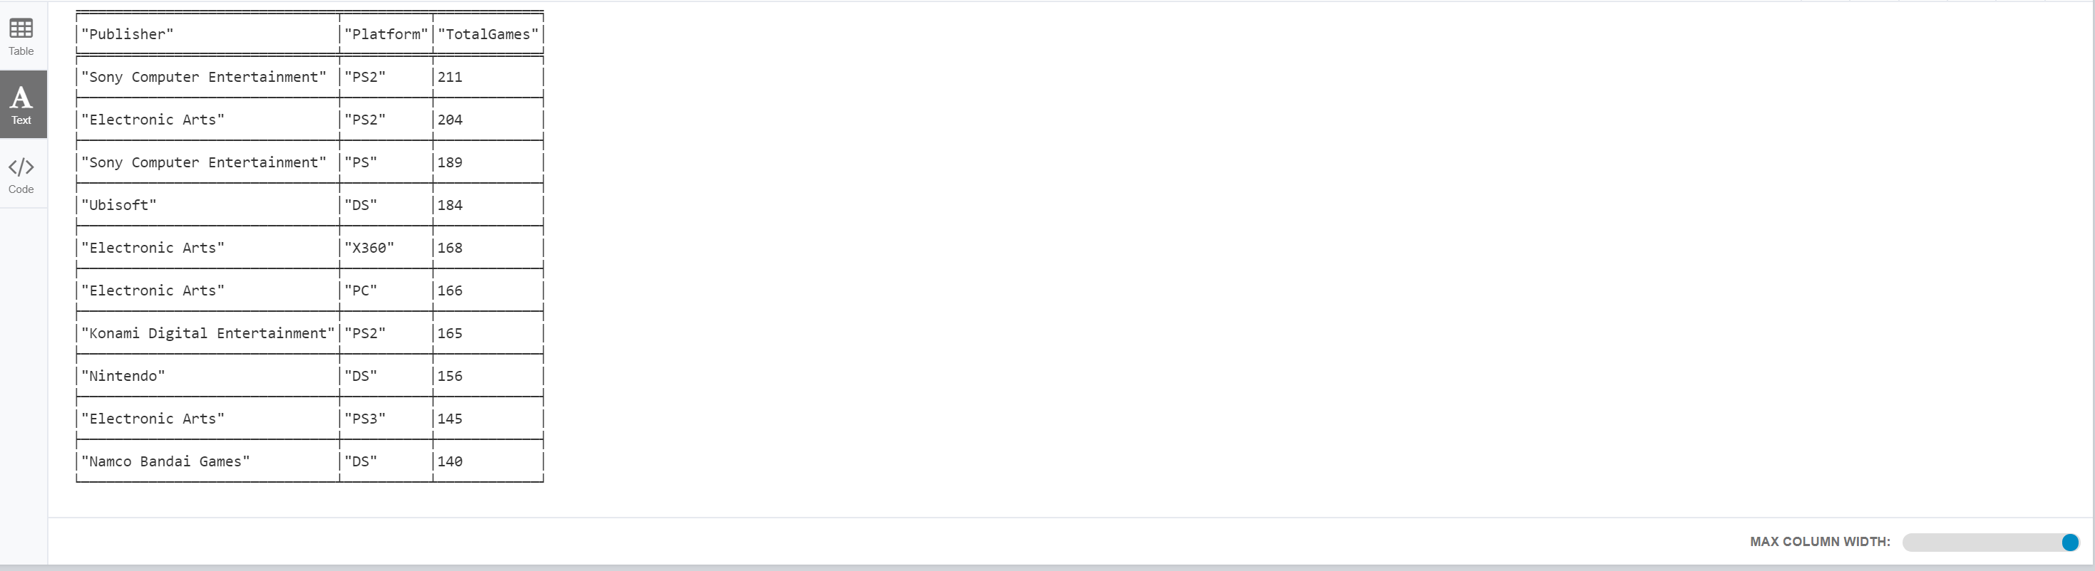

**3.7 ANALYSIS BASED ON PUBLISHER TO YEAR**

***🡪*** *From the chart below, we can infer that Ubisoft had maximum games published in 2008 & 2009, but yet the sales were high for Nintendo & Electronic Arts*

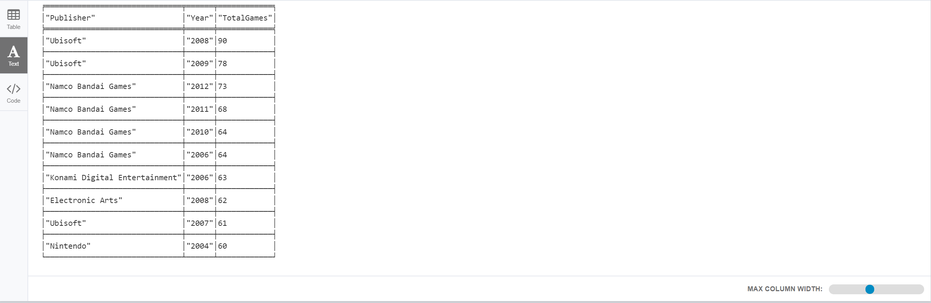

# VERIFYING GRAPH ANALYSIS WITH TABLEAU

Tableau is a Business Intelligence Tool utilized for information representation. It empowers us to make intuitive and able perceptions in type of dashboards, worksheets to pick up business bits of knowledge for the better improvement of the organization. It permits non-specialized clients to effectively make redid dashboards that give knowledge to a wide range of data. Business knowledge is among the perspectives in associations that have picked up significance throughout the years. Utilizing this Tableau, the day by day translation of the information at office work has moved toward becoming parcel less demanding in the current days. The product not just answers the question in an exact way as trained by us, it additionally shares understanding in a protected and simple route contrasted with other BI devices.

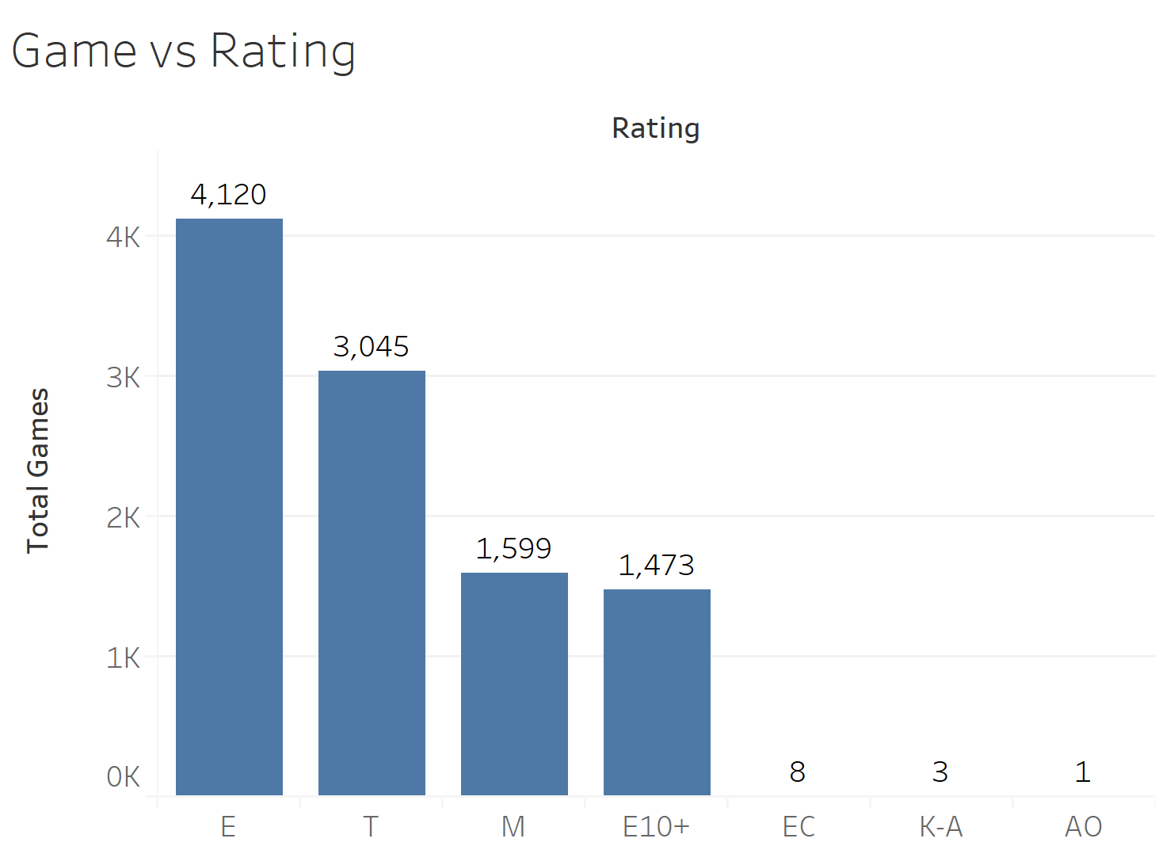

* *Games with “E” rating are mostly developed so that all age groups can enjoy. Followed by games for Teens*

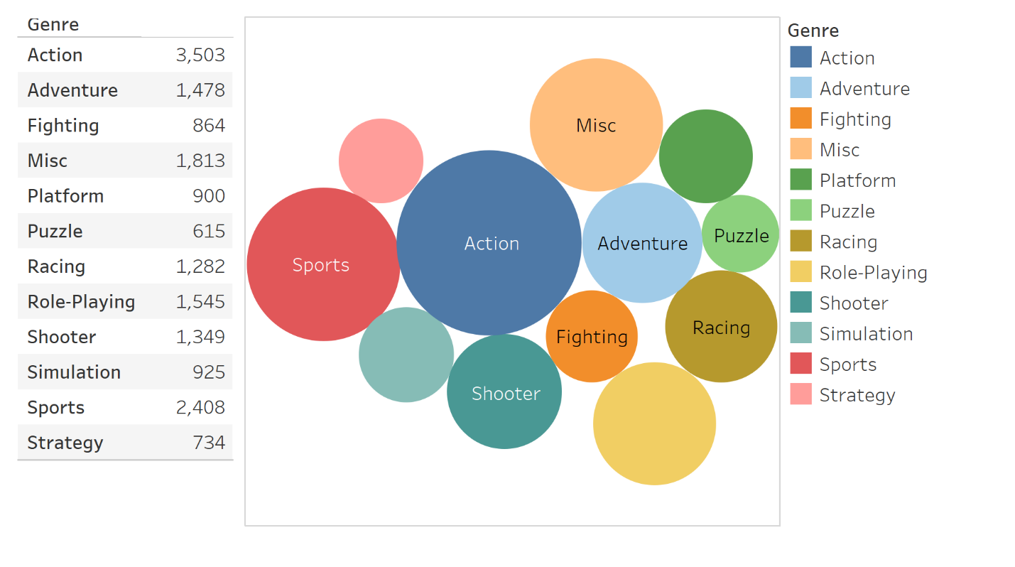

* *Games of types “Actions” & “Sports” are amongst the top 2 types*

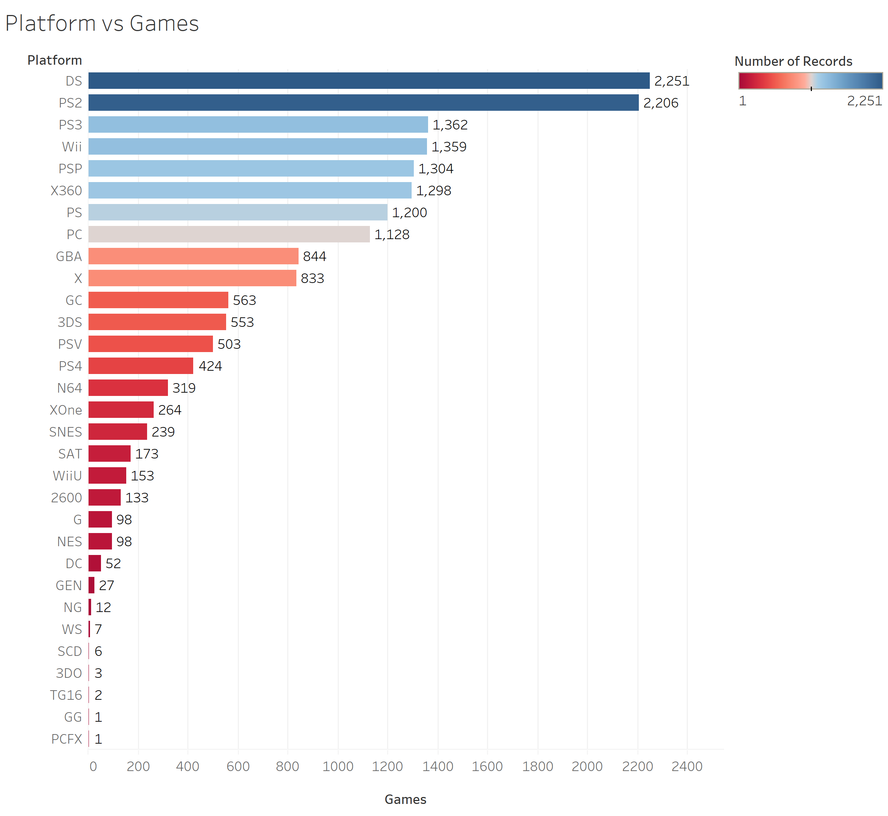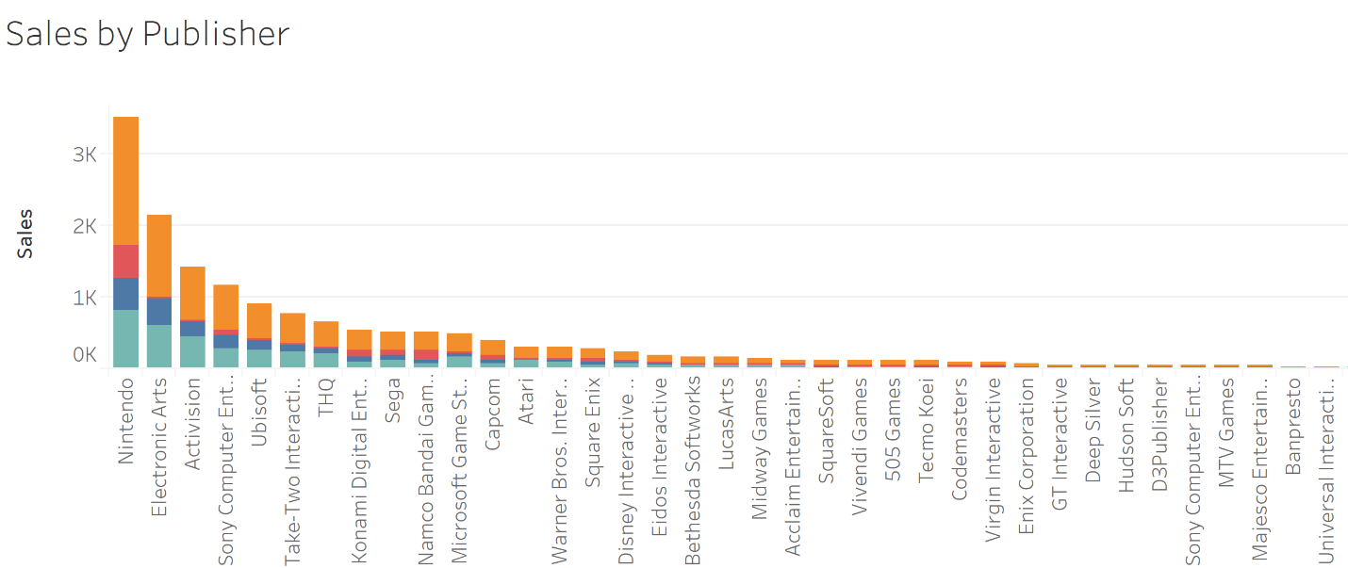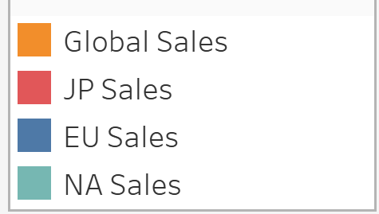

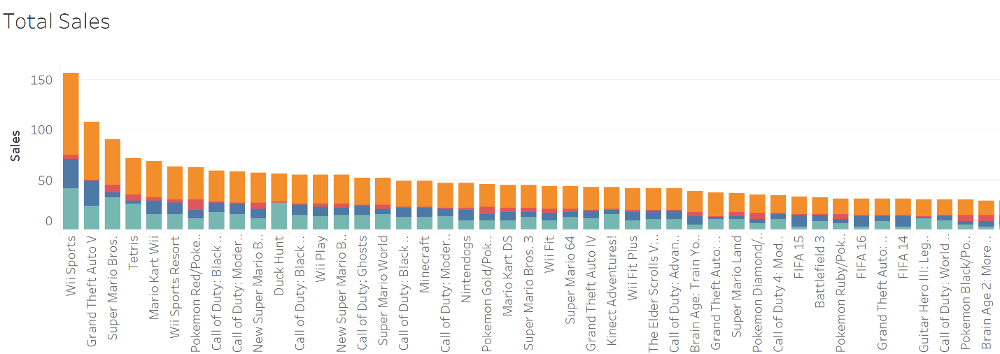

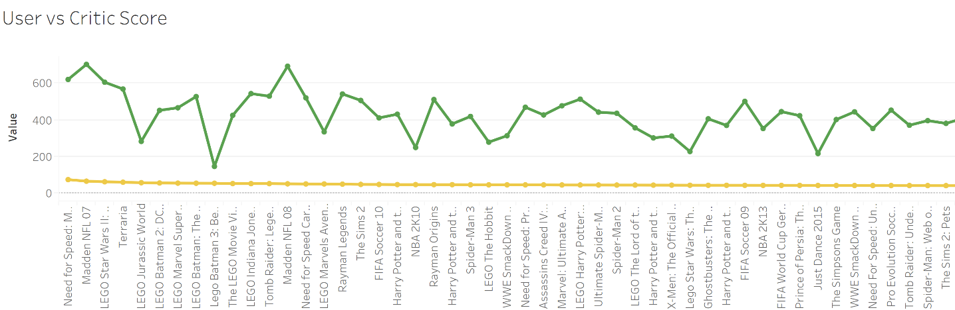



# CONCLUSION:

By the above analysis, Graph shows the relationship between the Video Games and Sales, user & critic scores as well as ratings in a lucid manner. The Graph Analysis is also verified with the help of Tableau. Based on the analysis, video game vendors can take necessary actions based on the results to increase their sales or add additional features to make games popular among users as well as get a high critic score. Graph Analysis also helps in understanding the user’s game references and trends.Thus, the graph database is particularly improved to store and navigate these charts of associated information. By instinctively mapping information and the associations between them, Graph database powers smart, ongoing applications that handle the present hardest endeavour challenges, including Artificial Intelligence (AI), The Internet of Things (IOT), Real-time proposals and personalization, Master information administration, Fraud identification, Network and IT operations, Identity and access administration etc.

# REFERENCES

* Morstabilini, Andrea (July 15, 2011). "Book Review: The Guide to Classic Graphic Adventures". Adventure Gamers. Archived from the original on July 14, 2016. Retrieved June 21, 2016.
* Mulrooney, Marty (November 17, 2011). "BOOK REVIEW – Hardcoregaming101.net Presents: The Guide to Classic Graphic Adventures". UK: Alternative Magazine Online. Archived from the original on July 23, 2016. Retrieved June 21, 2016.
* The International GeoGebra Institute (April 2013). "GeoGebra Non-Commercial License Agreement". GeoGebra website. Archived from the original on 13 January 2014. Retrieved 13 January 2014.
* "Welcome to Gnumeric!". Archived from the original on 16 December 2013. Retrieved 13 January 2014.
* The Definitive Space Invaders". Retro Gamer. Imagine Publishing (41): 24–33. September 2007. Retrieved April 20, 2011.
* J. P. Wolf (2008). "Video Game Stars: Pac-Man". The video game explosion: a history from PONG to Playstation and beyond. ABC-CLIO. p. 73. ISBN 0-313-33868-X. Retrieved April 10, 2011. It would go on to become arguably the most famous video game of all time, with the arcade game alone taking in more than a billion dollars, and one study estimated that it had been played more than 10 billion times during the twentieth century.